Little Firs Day Nursery Self Evaluation Form (SEF) tells the story of our nursery, it paints the picture of the rich experiences the children have every day. It is an up to date document which is regularly reviewed and updated.

**PLEASE READ & ENJOY THE STORY OF OUR NURSERY.**

**SEF IS ORGANISED IN THESE SECTIONS:**

Section 1: Our Nursery

Section 2: Parents, Children and Professionals Views

Section 3: Quality of Education

Section 4: Behaviour & Attitudes

Section 5: Personal Development

Section 6: Leadership & Management

Section 7: Evaluation and Overall Effectiveness

Section 8: Actions Plan- how we plan to move Little Firs Day Nursery forward

**OUR NURSERY.**



Westhaven Preschool opened in 1979 and Kids Club (Out of School Club) opened in 2000.

The Nursery moved into new accommodation within Westham Children’s Centre situated in the grounds of Conifers Primary School in January 2009 and renamed itself Little Firs Day Nursery. This was an exciting opportunity to work in partnership with Weymouth and Portland Sure-Start, Action for Children and Conifers Primary School. Unfortunately, Sure Start and Action for Children are no longer involved with Weymouth & Portland Children Centres, so we now work in partnership with Dorset County Council. We continue our working partnership with Conifers which enhances smooth transition into school.

The nursery is an accessible purposed built building with four classrooms; two preschool classrooms and two birth to three rooms, as well as a kitchen that provides healthy cooked food for the children. There is a balance of adult-led and freely chosen or child-initiated activities, delivered through indoor and outdoor play.



**MISSION STATEMENT**

Our Mission Statement is to provide a happy stimulating environment where children become engrossed in their play, thrive, and grow and develop their talents, whilst developing into independent and confident children that can meet their full potential.

**ETHOS**

Children are at the heart of our Ethos as we believe children learn best when they enjoy what they are doing, feel secure, calm, happy and self-assured.

Staff have high expectations for the children and enthuse and motivate them to explore and develop their learning. All children are included in all activities, and we aim to provide effective learning opportunities for all children using well planned experiences both indoors and outdoors that link to all seven areas of learning. To achieve this, we work in partnership with the parents and carers.

We put Inclusion at the heart of our practice and procedures and believe that being inclusive means that we are doing the best for everyone.

We promote British Values-Democracy, Rule of Law, Individual Liberty, and Mutual Tolerance-these are embedded into our diverse curriculum and teaching practice. This ensures that the children learn acceptance and respect for all cultures, faiths, and lifestyles.

**AIMS**

Our Aim is to provide high quality care and education through a range of challenging, educational play experiences both indoors and outdoors that are relevant to each individual child, whilst working closely with our parents and carers to promote and enhance the children’s learning. From this the children learn about respecting others, cooperation and sharing and learn about being true to themselves and respecting the rights of others.

**OBJECTIVES.**

Our objectives are that children develop a positive attitude towards health and wellbeing and to promote positive behaviour and respect of others. To ensure this we make the most of the children’s abilities and talents whilst supporting them to be confident, independent children that are school ready.



**Little Firs Day Nursery is a Rights Respecting Setting.**

We are registered for a maximum of 77 children to attend at any time and to provide care and education for children age 0-11 years. Opening times are Monday to Friday 07.30 until 18.00, for approximately fifty weeks of the year; one of these weeks is used for staff training days-

There are currently 117 children aged 0-five years and 40 children 5-11 years attending our Kids Club.

We are registered to take the Government’s Early Years Free Entitlement (EYFE) including two-year funding, three- and four-years funding both the 15 hours and 30-hour funding, Early Years Pupil Premium, Childcare Vouchers and the Government Tax Free Childcare.

The children come from wide and varied backgrounds; within this number are children with English as an additional language (EAL) including Arabic, German, Hungarian, Polish, and Portuguese.

Our children with additional needs include children with sensory impairment, speech and language delay and children with SEN Support. Mrs Chegwidden is our highly qualified Special Educational Need Coordinator (SENCO) andis super-numeral and supports the children with additional needs and liaises with professionals working with these children to enhance their progress. Furthermore, the SENCO assists the child’s keyperson to support the children’s additional needs and follow their Person-Centred Plans (PCP).

The SENCO follows the SALT’s language programmes and works with the child’s keyperson and their parents to ensure an integrated approach. Four other staff have qualifications in special needs and some staff have received training in PEIC-D which is used to support the children to develop their non-verbal communication skills. The nursery promotes sign language and has signs of the week to enhance the children’s language development.

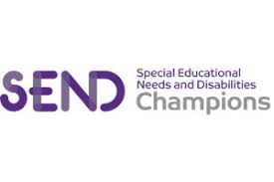Little Firs Day Nursery has gained the National Day Nursery Association (NDNA) Special Educational Need and Disability Champion Setting 2019.

The Nursery employs 25 qualified practitioners and 10 staff have been with the setting for over nine years. The other 2 staff members are our cooks.

**27 Staff.**

|  |  |  |  |  |
| --- | --- | --- | --- | --- |
| Role: | Qualification. | Number of Staff | Working towards a qualification | Level of qualification |
| **Manager** | **BA Degree & Early Years Teacher (EYT)** | **1** |  |  |
| **Assistant Manager** | **BA Degree & Early Years Teacher (EYT)** | **1** |  |  |
| **Deputy (SENCO)** | **Level 3** | **1** |  |  |
| **Heads of Room** | **Level 3** | **2** |  |  |
| **Deputy Heads of Room** | **Level 3** | **2** |  |  |
| **Practitioners** | **Level 3** | **13** |  |  |
| **Practitioners** | **Level 2** | **5** | **3** | **Level 3** |
| **Cooks** |  | **2** |  |  |



All childcare practitioners are First Aid trained and the nursery achieved the status of Millie Mark 2019.

All staff attend safeguarding training regularly and the nursery has clear safeguarding recruitment procedures in place which includes all staff having enhanced DBS checks and these are updated every three years. They have also completed the NDNA Prevent Duty Qualification.

**Section 2: PARENTS, CHILDREN AND PROFESSIONALS VIEWS.**

**PARENTS VIEW.**

We focus on our iconnect system to relay information to parents and them to us. Little Firs is a committee run group and all parents are welcome to join. We hold regular committee meetings to obtain their views and we work very closely with all our parents and their views are important to us.

Communication is an important way of how we obtain our parents views. The Management Team makes every effort to be around the Nursery between the start and the end of day for informal contact and stand on the gate to welcome and say goodbye to all children and parents. This gives parents opportunities to talk to the management team and express their views.

To enhance communication, we have a key-person system that promotes parent partnership and enables the parents to have a port of contact to discuss concerns or relay information and parents openly communicate with their key-person and the other staff.

To further develop parent partnership, we invested in an online e-learning journal system where parents can see their child’s learning and input comments about their child’s learning and what they have learnt outside of nursery.

We provide further opportunities to obtain parent views including celebrating their festivals and providing the parents with information and these include newsletters, parent notice boards, our Website, e-learning journals, welcome booklets, welcome book for children, tasters and this document.

From feedback from our parents we have changed our menus and this has inputted on our objectives to educate the children and families about healthy eating. Another change was that parents wanted an earlier start time of 7.30am. This enabled parents to be more flexible at work. Also, the roads are very busy by 8am and this enables the parents to plan their journey to work so they are not late.

**CHILDREN VIEWS.**

We obtain most of the children’s views by talking & listening to them; they are confident in selecting their own resources and activities and requesting further resources to extend their play. Little Firs is a Rights Respecting Setting and we listen to our children and they understand their rights and children’s voices count. This includes coming up with the settings Golden Values, ideas and impacting changes.

Staff plan around the children’s individual interests and needs, and staff review and evaluate session plans, as well as observing the children’s play to see what they are enjoying and what they are not.

**STAFF VIEWS.**  
Little Firs works as a team where everyone’s opinion counts, and staff are listened to with their ideas. We obtain our staff views from communicating with them. We have staff meetings, here they offer opinions in how the setting is run, evaluate what we offer the children and make changes to practice. The rooms have an idea board so that staff can put up their ideas for activities and have whole staff training days, where staff opinions and ideas are important, and staff are made to feel valued.

Staff can also speak to management at any time and are welcome to visit the office.

Little Firs Family Tree is a clear structure which explains where staff can go for support, advice or discuss any concerns; it also explains the ‘higher hierarchy.’ Staff line-managers conduct their staff supervision, they are asked about their views on practice and procedure, safeguarding concerns and any training needs that they have.

**OTHER PROFESSIONALS.**

We work successfully with professionals that are involved with our children including Speech and Language Therapists, Portage Consultants, Social Workers, Advisory Teachers and other professionals to provide the support the children need and to safeguard them. The Manager and the SENCO attend regular meetings with professionals and input on their EHCP’s, PCP’s, Child Protection and Child in Need Plans and PEP virtually.  
Our Local Authority Support is minimal, but we know where to get help and support and the Manager emails the settings Early Years Consultant to clarify issues and get advice. We also achieved level 1-outstanding the highest award for our safeguarding audit from the local safeguarding board.  
We work in close partnership with Conifers Primary School and the Head of Reception and the other Reception Teacher are on our committee. We hold meetings to discuss partnership working, school readiness and discussions on how to provide smooth transition. We also have a transfer meeting where the manager, the nursery’s SENCO go through the children’s developmental stages and individual needs with the Reception Teachers and Conifers SENCO. Our SENCO talks about SEND and extra support; this ensures the children’s individual needs are met and provides smooth transition and gives the Reception Teachers a clear baseline. Furthermore, Teachers from other schools visit the nursery and they have a discussion with the child’s keyperson about the child’s developmental stage and any needs; this gives the children the same opportunities as their peers.

**SECTION 3: QUALITY OF EDUCATION.**

Our Staff have high expectations for the children and enthuse and motivate them to explore and develop their learning, whilst working in partnership with the parents and carers. To ensure this we have two Early Years Teachers who mentor and train staff and implement changes to teaching practices which improves the outcomes for the children.

**THE CURRICULUM.**

At Little Firswe recognise that children learn in different ways and at different rates and plan for this accordingly. Our aim is to support all children attending the nursery to achieve their full potential. We achieve this by providing a positive stimulating and secure play environment enabling children to develop in all areas of learning whilst supporting emotional security and promoting equality, diversity and British Values.

We follow the Statutory Framework Early Years Foundation Stage 2021 and use the Development Matters Guidance 2021 to ensure all children learn and develop to their full potential. We support and enhance the children’s learning and development through active play-based activities which are interesting stimulating and challenging, that meet all the needs of the children. Practitioners expand the children’s play by following their interests, what the children can do, know, understand and their individual needs to develop their learning and development.

Little Firs ensure that our curriculum is well planned and resourced so that it covers the seven areas of learning. Our planning is based on a secure knowledge and understanding of child’s development, what our children can already do, know and understand following their interests and their needs so we can promote their learning and development further. We use research-based initiatives to enhance our curriculum further. These include language-based programmes, Story-making-bringing stories to life, Making Maths Real, Real-weekly nursery rhymes, and stories, I CAN-Talk Boost-a targeted language programme and funky fingers-developing fine motor skills to support pencil control. We support emotional security and behaviour with the Incredible Beginnings programme which supports the children’s personal and emotional well-being and supports positive behaviour.

We evaluate and review our curriculum, so we can respond quickly to children’s learning and developmental needs. We provide activities based on observations which inform future planning which draws on the children’s needs and interests. This is promoted through a balance of adult-led and child-initiated opportunities both indoors and outdoors.

Furthermore, we evaluate the impact that our curriculum has on the progress children make in their learning including:

* Baseline assessment including parental contributions
* WellComm-a screening tool to support and assess the children’s language
* I CAN-Talk Boost Programme
* Two-year-old progress checks (where applicable)
* Termly Summary of what the child has learnt that term, including what they know, can do and understand and what their next learning needs are, including their parent’s comments.
* Transition Summary when children leave.

The child’s keyperson creates an online e-learning journal which demonstrates each child's individual learning and development, showing their abilities, progress, interests and the areas needing further staff, parental support or professional assistance.

We acknowledge parents as primary educators and encourage parental involvement as outlined in our Parents and Carers as Partners policy.

**For further information on Teaching Practice-Please see Section 4.**

**TREASURE BASKETS.**

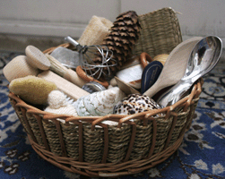Our Treasure Baskets contain collections of mostly natural materials that are especially chosen to give a richly sensory experience for babies and young children. Treasure Baskets provide the first opportunity to free play independently from an adult and endless opportunities to learn through play, they encourage problem solving, exploring, questioning and discovery, whilst promoting physical development.

**SENSORY PLAY.**

Sensory play is a key area of play and is a crucial part of children’s development. Sensory play involves the use of one or more of the senses. Young children learn best when they can experience new things using all their senses; they need to see, hear, touch, smell, balance and move two separate body parts together in order to really understand a media or material fully.

**MESSY PLAY.**

In messy play the children become more creative because they are using objects in new ways, combining objects, and trying new ideas. Children enjoy messy play because they are free to explore these fun sensory experiences, which stimulates their curiosity and encourages them to want to learn new things.

Other benefits are there is no obligation on creating an end-product and the children build relationships as they interact with their peers.

**FUNKY FINGERS.**

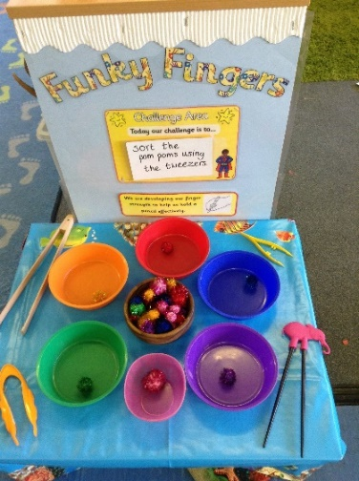We plan Funky Finger activities to support and extend the children’s development of gross and fine motor skills that are needed for pencil control. These are planned weekly considering the children’s physical developmental stage and we provide a variety of different sizes of objects, malleable materials and resources, which encourage the children to use their own fingers to manipulate them. These activities challenge and extend the children’s physical development and develop the skills needed for successful writing skills.

**COMMUNICATION & LANGUAGE DEVELOPMENT.**

We have a strong emphasis on developing children’s speech, language and communication skills. We promote the children’s language and communication skills through fun and interesting experiences.

The practitioners interact and listen to the children, answering their questions. The practitioners positively role model language, introducing new vocabulary, extending two-word utterances to build sentences and develop language skills to support their language development.

Our practitioners are ELKLAN trained, this high-quality training course provides resources, enabling practitioners to become effective in their support of children with speech, language and communication needs. This language programme supports language for the under threes and children with delayed language and uses some of ‘The Every Child A Talker Principles’ and includes the staff reviewing their practice in promoting vocabulary.

****Furthermore we assess the children’s language when they first start with us using the WellComm. Toolkit. This enables us to quickly and easily identify children needing speech and language support, which can make a crucial difference to their confidence and attainment. The age-appropriate ‘Big Book of Ideas’ provides a total of around 150 instant, play-based activities so we can take action straight away. The activities can be used at home too so that effective support is provided regardless of whether a child is referred to a Speech and Language Therapist

**Mrs. Chegwidden is our Communication & Language Coordinator and SENCO and supports the children with language development.**

**BABBLING BABIES.**

The Nestlings Room children have ‘Babbling Babies’ sessions. The children join in with rhymes, action songs and poems. Staff model language, using a running commentary and provide a language rich environment.

**CHATTER BOX.**

The Discoverers Room children have ‘Chatterbox’ sessions. Here the children join in with lip and tongue exercises, which help the children to make clearer speech sounds. They play games, including listening and sound games and the practitioners’ model and encourage the use of key words by using signs, which in turn supports the children’s development of spoken language. Children also enjoy singing sessions and story sacks.

Our parents are informed about the weekly Babbling Babies and Chatterbox activities in our newsletter and the planning is displayed on the parents notice board, so this can be reinforced at home, further developing the children’s communication skills.

**NURSERY RHYMES AND SINGING.**

Providing an environment rich in different sounds and interesting things to hear benefits the children immensely and it develops their communication skills, their literacy skills and reading skills. We understand the benefits from learning nursery rhymes and singing songs, as the children are introduced to new vocabulary, rhythm and rhyming, environmental sounds, instrumental sounds, body percussion, voice sounds, alliteration oral blending and segmenting. This supports the children’s language development, listening and attention skills and literacy skills. Starting phonics from an early age supports children to read.

We inform our parents about the song/nursery rhyme in our newsletter which is displayed on the parents notice board and on our website.

**RAISING EARLY ACHIEVEMENTS IN LITERACY. (REAL)**

This research-based programme aims to raise the achievements in literacy for young children to give them the best start. REAL is part of the language sessions. We plan a story, a song or nursery rhyme and signs of the week. These activities support the children’s communication skills, understanding of written and spoken word, listening and attention skills and spoken language, as well as developing their reading skills and showing them that books are fun. Our newsletter informs parents about the week’s stories, the signs and the songs. Parents are given copies of the songs and signs to provide the children with consistency and early language opportunities at home.

**SIGN ALONG.**

As part of REAL we have signs of the week; signs will enhance the children’s language development as learning sign language enhances pre-speaking skills and improves their communication skills.

**STORY MAKING.**

Pie Corbett’s Story Making programme is about telling a story together rather than reading it from books. It is a way of encouraging the children to learn and remember stories. Stories are told through actions which help children to memorise new words and patterns in a story. Story Making encourages a love of books and improves the child’s spoken language, their writing and imaginative skills and builds the children’s confidence in a fun and creative way.

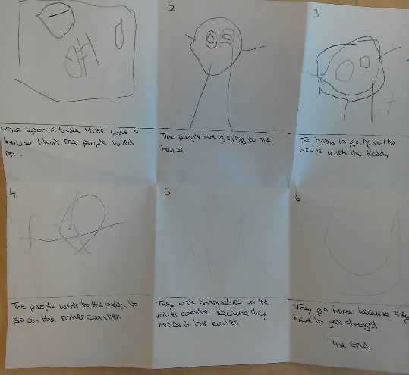The children are introduced to story maps, which is the pre-writing stage of writing a story. The older children are then encouraged to draw their own story maps which teaches them there is a beginning, middle and an end to a story; they make the story easier to learn and encourage the children to start to write their own stories.

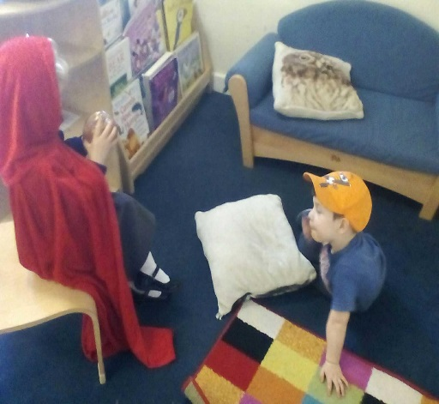

**BOOKS.**

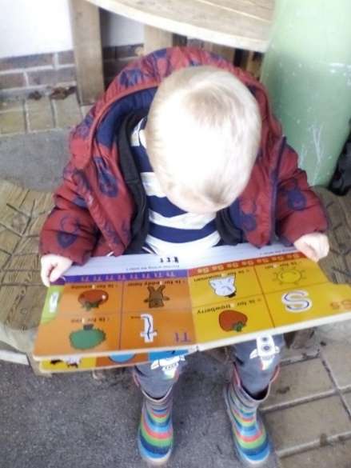

Children like to be held and spoken to and books provide the perfect opportunity for this as they learn about speech patterns and how to make sounds. Every time a child is read to, it reinforces basic reading concepts, such as turning pages and following text from left to right. Adults read a book to a child, pointing to the pictures and naming them, talking about them; this reinforces reading skills and extends the child’s vocabulary. Also, children love to copy adults, and this encourages them to copy turning pages or pointing to objects and naming them and through this positive experience children view reading as a pleasurable experience.

**MAKING MATHS REAL.**

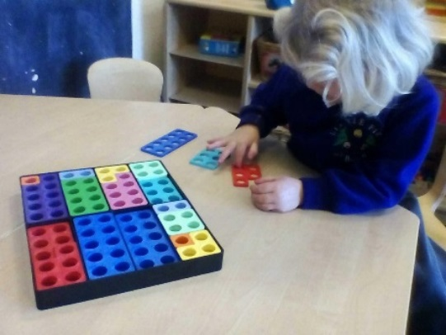This research-based programme follows on from the Raising Early Achievements in Literacy, but this programme aims to raise achievements for children in mathematics. This programme makes math’s real and fun for the children and there are three strands: Environmental Math’s this is the environmental numbers which surrounds young children in their home, in nursery and in the community.

Everyday Math’s -This is mathematics that the children might encounter and experience through everyday experiences. Stories, Songs and Rhymes- this is mathematics that the child might encounter and experience through stories, songs and rhymes.

**NUMICON.**

We use Numicon in the nursery, this is a multi-sensory approach to teaching maths developed by experts in the classroom. It has been designed to help children understand connections between numbers. Through the multi-sensory activities and mathematical language of Numicon, the children develop the understanding and skills that underpin their later understanding of number.

**PHYSICAL**

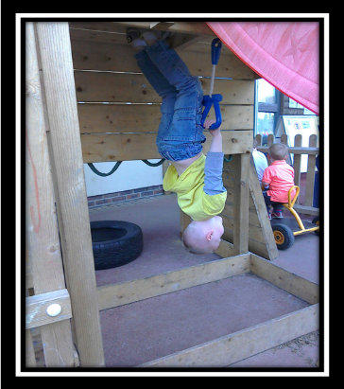We provide the children with lots of opportunities to develop their physical skills both fine and gross motor skills. As through physical exercise children progress in all areas of development, when they work together, they develop socially, when attempting or achieving new skills they develop emotionally and gain in confidence and independence and as they exercise their brain develops pathways and they develop their intellectual skills.

The children also learn about keeping themselves healthy and understand the importance of physical exercise and keeping safe.

**HEALTH & SELF-CARE.**

We provide healthy cooked food, snacks are fruit or vegetables and the children have their own water bottles, so they always have access to water. We educate the children on healthy diets to promote healthy eating and living. Previously we received Gold in all the Dorset Healthy Living Awards-Health & Well-being, Healthy Eating and Promoting Physical Exercise. All the children are encouraged to wash their hands after using the toilet, before lunch and snacks and the children all clean their teeth after lunch. All these examples are part of practice and teach the children hygienic practices. Also, the preschool children are encouraged to put on their own sun-cream.

To encourage their health and self-care the children and families are supported by Mrs Parker, with toileting issues. She has a persona doll called Belinda which the children take home with story-books and a potty; this supports the children’s well-being. Mrs Parker also supports the parents with literature and advice on potty training.

**EXPRESSIVE ARTS & DESIGN.**

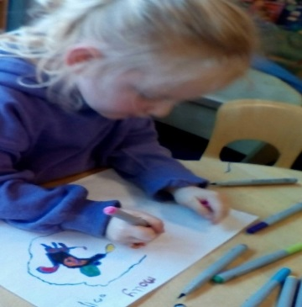We provide the children time to explore and experiment their ideas, materials, activities, thoughts and feelings and play co-operatively with each other. Our children are encouraged to participate in positive experiences to glue, paint, print and model. These opportunities help the children develop imaginative skills, experiment with materials, plan and solve problems and gain confidence from creating something of their own.

We develop their imaginative skills by providing role play activities and these are a valid part of our planning and we aim to reflect “life experiences” where children are given the opportunities to dress up and take on various roles.

**SINGING.**

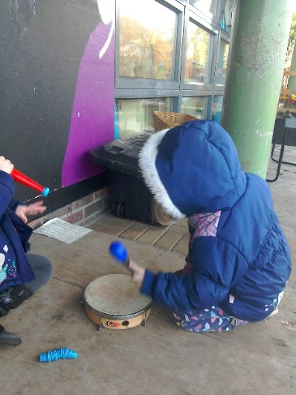We understand the benefits that singing has on communication and language development, as they are introduced to vocabulary, rhythm and rhyming; this supports the children’s communication skills especially phonics and literacy skills. We provide an environment rich in different sounds and interesting things to hear as this develops their communication, imaginative and creative skills.

Singing is part of everyday practice; we have weekly nursery rhymes or songs which parents are given copies of to encourage them to be actively involved.

A Department for Education Survey showed that if a child can recite 8 nursery rhymes by the age of 4 years, they will most likely be in the top group of readers by the age of 8 years.

**SECTION 4: BEHAVIOUR & ATTITUDES.**

Our aim is to provide a welcoming secure environment which supports the children’s emotional well-being and it is clear to see that our children are confident learners who are secure in the nursery’s environment and understand how to respect others, be kind and have positive behaviour. The children are supported with this by the Nursery being a Rights Respecting Setting and the children created the Golden Values. This has empowered the children to try and understand right from wrong; it has also promoted positive behaviour amongst the children, teamwork and problem-solving skills. All practitioners encourage and model appropriate language and role-model positive behaviour and they use the Golden Values to remind the children how to be kind and respect others. The nursery also has a clear bullying policy. All this ensures the children learn positive behaviour skills, how to play cooperatively and respect others.

**POSITIVE BEHAVIOUR.**

The nursery has clear policies and procedures in place to support behaviour management and the children has created the Golden Values. This has empowered the children to understand right from wrong, it has also promoted positive behaviour amongst the children, teamwork and problem-solving skills.

All practitioners encourage and model appropriate language and role model positive behaviour and use the Golden Values to remind children about them and how to be kind and respect others. The nursery also has a clear Anti-bullying Policy; this ensures that the children are learning how to behave well and play co-operatively.

**Mrs Chegwidden SENCO supports Positive Behaviour Management.**

**Please see our policies for information on behaviour management these can be found on our Website, in all the rooms and the Hallway.**

**INCREDIBLE BEGININGS PROGRAMME-INCREDIBLE YEARS.**

[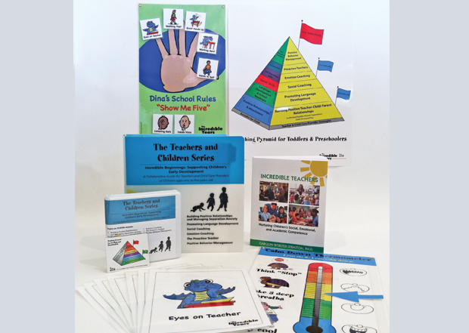](http://www.google.co.uk/url?sa=i&rct=j&q=&esrc=s&source=images&cd=&ved=2ahUKEwiU29HNkfDfAhWJ4YUKHYIsD4IQjRx6BAgBEAU&url=http%3A%2F%2Fwww.incredibleyears.com%2Fprograms%2Fteacher%2Fincredible-beginnings-program%2F&psig=AOvVaw1MFfDXZyxqFFaI4US-Qbjx&ust=1547653740762178)To support positive behaviour, we follow the Incredible Beginnings Programme-Incredible Years. The programmes teaching methods include social and emotion coaching, nurturing child-directed play, interactions using narrated descriptive commenting, proactive teaching with predictable routines and consistent positive behaviour management strategies. All these sensitive and responsive approaches build positive relationships with the children.

The outcomes from using this programme has increased the children's personal, social and emotional well-being, there is a reduction in the number of reported behaviour concerns in the nursery and the children have learnt strategies to deal with their emotional out-burst and feelings.

The outcomes for the staff are that they have increased their skills and confidence in dealing with behaviour issues.

**Mrs Parker, Mrs Lund and Mrs Chegwidden are all Qualified Facilitators in the Incredible Beginnings Programme-Incredible Years.**

**RIGHTS RESPECTING SETTING.**

We are a Rights Respecting Setting, which means we put the rights of the child at the heart of everything we do and encourage the children to be positive global citizens.

An important part of being a Rights Respecting Setting is having a Charter linked to the UN Convention on the Rights of a Child, which supports the children to understand their rights and responsibilities.

|  |  |
| --- | --- |
| **logo**  **Little Firs Day Nursery Charter.** | |
| **RIGHTS** | **RESPONSIBILITES** |
| **We have the Right to**  **Play & Rest (31)**  **Your education should help you use**  **and develop your talents and abilities. It should also help you to learn to live peacefully, protect the environment and respect other people. (29)**  **We have the right to our own opinion and for adults to listen and take us seriously. (12)**  **You have the right to the best health care possible, safe water to drink, nutritious food, a clean and safe environment and information to help stay well (24)** | **We learn through play.**  **We try to share and take turns, care and be a kind friend.**  **We try to work hard and reach for the stars.**  **We try to learn about respecting others.**  **We try to learn to care for our environment.**  **We try to follow our Golden Values.**  **We try to voice our opinions.**  **We try to be polite.**  **We try to listen to others.**  **We take turns in talking.**  **We try to understand that the things our friends say are important.**  **We learn about what we need to do to stay fit and well.**  **We try to learn about staying healthy.**  **We try to eat healthily**  **We have access to fresh water.**  **We try to keep our environment safe.**  **We learn about staying safe.** |



Little Firs Day Nursery

Golden Values

**At Little Firs we learn to follow our hands and kind feetHave kind mouths (we do not bite)**

**Little Firs Golden Values 2022-23.**

**At Little Firs we learn to follow our Golden Values.**

**We are kind friends and polite.**

**We respect one another and treat everyone fairly.**

**We try to:**

* **Share and take turns**
* **Be kind**
* **Be gentle**
* **Have kind hands and kind feet**
* **Have kind mouths (we do not bite)**
* **Use kind words**
* **Use our listening ears and take turns to talk**
* **Be helpful and care for our friends**
* **Play and have fun and play with everyone**
* **Tidy up and look after our toys and Nursery**

***We learn that Little Firs stands for:***

***Listen***

***Interact***

***Tolerance***

***Thrive***

***Learn***

***Enjoy***

***Fun***

***Imaginative***

***Respect***

***Stay safe***

**SECTION 5: PERSONAL DEVELOPMENT.**

We promote British Values, and these are embedded into our diverse curriculum and teaching practice. This ensures that the children learn acceptance and respect for all cultures, faiths and lifestyles. There are clear procedures in place to keep the children safe and protected from radicalisation and extremism and all staff have undertaken the prevent duty and channel training. Parents have supported the nursery to include their home-language by providing recordings of well know stories and have helped us provide activities around their festivals. An example is Holi-the Hindi festival of colours. This has helped the children to understand their friend’s cultures and beliefs and has encouraged mutual respect and positive behaviour. We also have a Lingua Talking Pen which the practioners uses so that the children can hear their home language in the setting and to assess their home-language skills.

Our key-person system ensures that we develop a secure attachment with the children and their parents. Parents are given information about their child’s key-person when they start at the Nursery; this includes the key-person photograph, information about their qualifications and experience and their key-group name. Our key-person system ensures that all practitioners know their children and understands their developmental stage. A base-line assessment is carried out when the child starts. This gives a clear starting point as to where the child’s developmental stage is and any additional needs. Parents are involved in this process and provide vital information to the key-person about their child. There are parent interviews termly and the key-persons and parents discuss the children’s progress and any concerns. To further establish their relationship, all key-persons have Teddies which their key-group is named after.

**Please see Section 3 to find out more about our curriculum, e-Learning journals, observations and assessments, taster sessions and our teaching practices.**

Our routines encourage the children to work independently and in small and large groups. This supports and inspires playing & exploring, active learning, creating and critical thinking and develops positive attitudes to learning & school readiness. This includes nappy changing in the baby room as part of their planned care & routine. We use picture exchange communication systems (PECS) so children with SEND can show the pictures for what they need-like drink, toilet etc. This improves their learning outcomes for the future and their communication skills.  
To ensure the children feel secure, safe and to support emotional well-being the practitioners reviewed practices and changed the rooms around to encourage free flow and implemented more child-initiated activities that follows the children’s interest. The Baby & Toddler practitioners changed the sleep area in the Birth to Three Unit to ensure emotional well-being and had the cloakroom removed to extend the play areas and for safety reasons. Furthermore, they evaluated the environment and changed it so that Nestlings (Babies) and Discoverers (toddlers) now work more closely together as a Birth to Three Unit. This has supported smooth transition and attachment bonds, promoted emotional well-being and provided consistency with care and education.

The nursery uses Leuven’s involvement and well-being scales. This assesses how involved the children are in their play and how stimulating our activities are and assesses their emotional well-being. These scales help the setting alter the environment and the opportunities to support the children’s emotional well-being and enjoyment in the learning opportunities we offer. This enables the children to become self-aware and confident learners that explore their surroundings, use imagination and who are happy, enjoy learning and achieve.

**INCLUSION.**

We put inclusion at the heart of our practice and procedures and believe that being inclusive means that we are doing the best for everyone. We celebrate diversity and develop a sense of community and belonging and have a high expectation of every child, as this is vital for their future life chances. We treat all the children fairly showing no anti-discriminatory and anti-bias practice or stereotypical practice. This is not achieved by treating the children the same, but by treating them as individuals, in order that their own personal needs are met.

Little Firs promotes British Values, and these are embedded into our diverse curriculum and teaching practice and ensures that the children learn acceptance and respect for all cultures, faiths and lifestyles.

**Equality Named Coordinator ENCO: MRS PARKER**

**Special Educational Need Coordinator SENCO: MRS CHEGWIDDEN.**

**SECTION 6: LEADERSHIP & MANAGEMENT**

Little Firs believes that well motivated and enthusiastic staff empower the children to appreciate that learning is fun. The management team are highly qualified and motivate, mentor and support the staff in all areas of their roles. We have a clear staff structure (Family Tree) the Head of Rooms are Line Managers to their staff team and support, guide and deliver staff supervision. Staff supervision incorporates discussions about their key-children, including the child’s progress, any concerns they have with their development and any safeguarding concerns. The staff get feedback on their performance. If they need support, action plans are put in place with support, guidance, mentoring and training.

The nursery has 5 staff training days where new initiatives are implemented into practice and old practices are revisited and reviewed. These have included the new Development Matters, Making Maths Real, Raising Early Achievements in Literacy (REAL), Story-Making, Safeguarding, ELKLAN, WellComm and many more. These have positively impacted on the children’s learning and development, including children with Early Years Pupil Premium (EYPP) and Two-Year Funding-**Please see section 3, 4, 5, 7 & 8.**

**Mrs Parker is the Nursery’s Attendance Officer** and parents are informed that they must notify the nursery of absences and the reason for the absence on the first day and then update regularly throughout the absence. If the Nursery has not heard from the parent/carer within a reasonable time the nursery will telephone the parent/carer to establish why the child is absent. If we are concerned about the welfare of the child, the Multi Agency Safeguarding Hub (MASH) will be contacted following the Safeguarding Policy and Procedures as the welfare of the child is paramount.

**Mrs Chegwidden is the Nursery’s Communication & Language Co-ordinator** and has qualifications in Special Educational Needs, Psychology, Mental Health and Communication and Language. She uses the Derbyshire Language Scheme and ELKAN to improve and support the children’s language skills and works alongside a Speech & Language Therapist (SALT) who visits the nursery and follows the SALT’s language programmes and works with the child’s keyperson and their parents to ensure an integrated approach.

**POLICIES & PROCEDURES:**

The nursery has clear up to date policies and procedures and these are reviewed by the committee and the staff regularly. **These can be found on our website and there are copies in all the rooms and in the hallway.**

**SAFEGUARDING**

The Nursery understand their responsibilities in meeting the Safeguarding Welfare requirements of the EYFS. We have a named Designated Safeguarding Lead (DSL) and two Deputy DSL’s who all clearly understand their roles and responsibilities. They are level three qualified, and this is updated every three years. Other courses they have attended are the Role of DSL, Safer Recruitment, e-Safety, Prevent Duty, Channel, and CAF. All other childcare practitioners have level 2 Safeguarding Qualifications, Prevent Duty and Channel Training.

Little Firs promotes British Values, and these are embedded into our diverse curriculum and teaching practice and ensures that the children learn acceptance and respect for all cultures, faiths and lifestyles. There are clear procedures in place to keep the children safe and protected from radicalisation and extremism.

**Please** **see our Child Protection & Prevent Duty Policies and Procedures. These can be found on our website, there are copies in all the rooms and in the hallway.**

**STAFF RESPONSIBILITIES:**

|  |  |
| --- | --- |
| Role: |  |
| Designated Safeguarding Lead (DSL) | Wendy Parker |
| Deputy Designated Safeguarding Leads  (DSL) | Michele Lund,  Janice Chegwidden |
| E-Safety Champion | Michele Lund |
| Attendance Officer | Wendy Parker |
| Special Educational Needs Co-ordinator (SENCO) | Janice Chegwidden |
| Equality Named Co-ordinator (ENCO) | Wendy Parker |
| Health & Safety Officer | Michele Lund |
| Fire Wardens | Wendy Parker Michele Lund  Janice Chegwidden |
| First Aid Trained | All staff |
| Named Person for Communication & Language Development | Janice Chegwidden |

**HEALTH & SAFETY.**

The staff carry out risk assessments daily and the Health and Safety Officer carries out full risk assessments of the building termly including Covid19 Risk Assessment. The children are provided with opportunities to understand how to keep themselves safe and the preschool children carry out their own tick sheet risk assessment and discuss and learn how to keep germs from spreading.

The nursery has termly fire drill practices so that the staff and the children are aware of the procedure and fire drill reports are kept and reviewed and evaluated so that issues can be addressed. All fire alarms and equipment are checked weekly and the fire-wardens understand their roles and responsibilities.   
The children are encouraged and supported to wash their hands after using the toilet, before eating and preparing food and they clean their teeth after lunch.

**SECTION 7: EVALUATION & OVERALL EFFECTIVENESS.**

**SELF EVALUATING & IMPROVEMENT PLANNING.**

All staff evaluate the educational programme by constantly reviewing and evaluating activities and the practices and procedures of the setting to ensure that the curriculum is varied, stimulating and challenges and motivates the children so they can excel in their development . The nursery invests heavily in staff CPD and this helps the staff have the knowledge to understand child development and introduces new practices and procedures into the nursery and improves the outcomes for the children and the staff.

Staff are reflective practitioners and have implemented changes including changing the rooms around to encourage free flow and implemented more child-initiated activities that follow children’s interests. Other changes have been changes to the Baseline Assessments and Transition Reports.

Other changes to improve parent partnership have been the introduction of key-person toys to enhance home learning.

After communicating with our parents, we created new Parental Booking Agreements and Welcome Booklets to ensure parents understood all our procedures and policies and our curriculum and learning programmes. We also reviewed our menus and started earlier in the morning following parents request. The nursery changed the sleep area in the Birth to Three Unit, to ensure emotional well-being and had the cloakroom removed to extend the play areas and for safety reasons. Furthermore, the staff evaluated the environment and changed it so that Nestlings (Babies) and Discoverers (Toddlers) now work more closely together as a Birth to Three Unit. This has supported smooth transition and attachment bonds and provides consistency with care and education.

From attending training, we implemented into practice Funky Fingers, Incredible Beginnings, Making Maths REAL, Planning in the Moment, Raising Achievements in Literacy (REAL), Story-Making, ELKLAN and WellComm.

The Raising Early Achievements in Literacy which has improved the outcomes in literacy and language skills; Story-making has supported literacy, creativity, imaginative skills and PSED, as well as Characteristics of Effective Learning; Making Maths REAL has improved the outcomes in Maths and supports Characteristics of Effective Learning; in addition the Funky Fingers stimulates all the crucial developmental stages needed for pencil control. The Nursery also monitors and evaluates the children’s learning, development and progress through Base-Line Assessments, Progress Reports, Person Centred Plans, Education Health Care Plans, Transition Reports and WellComm.

To ensure the children get the best possible start we employ two EYT’s who mentor and train staff and implement changes to teaching practices which improves the outcomes for the children. We also achieve this by our SENCO being super-numeral and using the Derbyshire Language Scheme, ELKLAN Training and resources and WellComm Toolkit to support and improve the children’s language skills.   
All practitioners know their children and understand what is expected for the child’s age and developmental stage. The key-person undertakes a clear baseline assessment when the child starts at the setting -parents are involved in this process. This gives the staff clear starting points for the children so they can provide an enriching stimulating curriculum that develops the children onto the next stage of their learning and provides vital information for ongoing assessment. This supports the children to become confident and keen learners who are ready for the next stage of their education.

The management team is proactive and supports the practitioners to improve all the outcomes for the children and meet the welfare requirements. The management all understand their responsibilities in meeting the Welfare requirements. Little Firs has a named DSL and deputies who all clearly understand their roles and responsibilities of safeguarding and the welfare requirements. All other staff are level 2 safeguard trained and these are updated every three years. This ensures that the children are kept safe.  
The Manager, Assistant Manager and the SENCO undertook the Incredible Beginnings programme. This has been implemented into practice and procedures and the outcomes from this course has increase children's personal, social and emotional well-being, a reduction in the number of reported behaviour concerns for children in the setting, increase the skills and confidence of the staff and decrease the stress levels of Early Years Practitioners in relation to managing children's behaviour  
The setting is very proactive in supporting children with additional needs including having a super-numeral SENCO who gives the children a curriculum that meets their needs. There are also clear procedures for supporting the most disadvantaged children when the staff and management have assessed the children’s needs, they provide a support package that enables the children to meet their full potential and narrows the gaps for those that might not achieve.  
  
**SECTION 9: ACTIONS PLAN- HOW TO MOVE LITTLE FIRS FORWARD.**

* Ofsted found that we were not yet outstanding as we have to improve staff's interactions with babies to engage them more effectively and meet their

next steps in learning consistently. To develop this the senior staff of the Birth to Three Unit will undertake the NDA Brilliant babies.

* Monitor more closely the temperature in the baby room to ensure that babies, particularly those who are not yet mobile, do not get cold. We have invested in more accurate room temperature gauges.
* Continue to implement into practice Storymaking, REAL, Making Maths Real, Funky Fingers and our Language initiatives.
* Continue to update all staff training and knowledge to further develop their professional development and introduce and implement new initiatives.
* Use the NDNA Training & Development for the Early Years Workforce to provide Continuous Professional Development
* To continue to develop transition to school and other rooms and to support school readiness in the children and change for all children.
* To continue to develop EAL resources so that the children can all hear their home language with the help from the talking together-learning together scheme
* The SENCO to continue to use ELKAN to support language for the under threes and children with delayed language and will enhance all our other language programmes.
* Continue to implement into practice the Incredible Beginnings Behaviour programme. The outcomes are to increase children's personal, social and emotional well-being, a reduction in the number of reported behaviour concerns for children in the setting, increase the skills and confidence of the staff and decrease the stress levels of Early Years Practitioners in relation to managing children's behaviour
* Continue to develop the WellComm Toolkit to provide a clear assessment on language development.
* Develop and Implement the I CAN TALK- Talk Boost Programme
* Continue to implement the new Development Matters into practice